2020-2021 Administrative Fellowship Program Information

Tampa General Hospital is a private not-for-profit hospital and one of the most comprehensive medical facilities in West Central Florida serving a dozen counties with a population in excess of 4 million. As one of the largest hospitals in Florida, Tampa General is licensed for 1,007 beds, and with more than 8,000 employees, is one of the region’s largest employers.

At TGH, we believe growing and developing leaders is the key to building a pipeline for future administrative talent and leadership. The Tampa General Administrative Fellowship Program consists of a year long rotation through several administrative departments such as Operations, Strategy, Human Resources, Finance, etc. Individuals develop a comprehensive understanding of a complex health care organization with a strong vision to be the safest and most innovative academic health system in America. TGH has a rich teaching and training history in medicine, we aim to provide a world-class teaching experience for future administrative leaders as well.

SECTION I: STRUCTURE

Advisors and Preceptor
Based upon areas of interest, fellows will be assigned a preceptor from one of the organization’s administrative functions. This preceptor will be responsible for engaging with the fellow throughout the program. Preceptors will do this through one-on-one meetings, mentorships, guidance, feedback on performance, and some project work during the one-year rotation. Donna Tope, MBA, MSHA, Director of Support Services and Tallee Williams, MBA, MSHA, Manager of Physician Wellness and Special Projects serve as the Administrative Fellowship Program advisors and will also work with the fellows throughout their one-year rotation.

The Tampa General Administrative Fellowship Program provides the opportunity to work with:
- President & CEO
- Executive VP & Chief Information Officer
- Executive VP & Chief Strategy & Marketing Officer
- Executive VP & Chief Operating Officer
- Senior VP & Chief Nursing Officer

Evaluations
Commitment and constant evaluation is crucial to ensuring success both during the fellowship and in future career endeavors. Throughout the program, quarterly evaluations will be completed between the fellow and their preceptor. The intent of completing these evaluations is to constantly evolve and ensure a fulfilling and engaging experience during the entire fellowship.

SECTION II: RESPONSIBILITIES

Expectations
Each fellow is to complete two major projects along with at least five other smaller projects
throughout the year. These projects should be tracked in a fellowship plan developed by both the fellow and the preceptor.

In addition to project work, all fellows are expected to follow a set of expectations that will allow for sufficient exposure and learning experiences. The expectations are as follows:
- Connect with and support other senior leaders within TGH
- Perform rotations and shadowing with different departments
- Gain exposure to various leadership styles, roles, and responsibilities within the organization
- Learn about leaders’ backgrounds by building professional relationships
- Network with developing leaders both inside and outside of the organization
- Serve as ambassadors of TGH in the organization and in the community
The fellows are expected to attend the following meetings:
- Two to three board meetings
- Monthly Senior Management team meetings
- Monthly Leadership Forum
- One to two Birthday Breakfasts
Fellowship Goal Setting
To keep track of the projects a fellow will be working on and to set tangible goals for each fellow’s administrative fellowship, every fellow is encouraged to develop a fellowship plan. The fellowship plan will consist of:
- Administrative fellowship purpose as defined by the fellow
- Meetings held or attended with senior leaders
- Personal and professional goals
- Project dashboard

SECTION III: APPLICATION REQUIREMENTS AND TIMELINE

Eligibility
Eligible applicants must have completed the didactic portion of their MBA, MHA or MPH. Due to the nature of the Administrative Fellowship Program and the expectations when performing project work throughout the organization, TGH’s Administrative Fellowship Program is a Master’s level position.

Requirements, to be submitted to https://www.tgh.org/careers
- Cover Letter
- Resume
- Graduate School Transcripts
- Two (2) Letters of Recommendation
  - Academic OR Program Director
  - Professional OR Personal
Application/Selection Process Timeline
Applications open and information is made available online at https://www.tgh.org/careers for Master’s students expressing interest: August 19, 2019
- Applications Close: September 30, 2019 at 11:59 PM EST
- Review of Applications and On-Sites: October 1-31, 2019
- Offer Date: November 11, 2019
- Deadline to Accept Offer: November 15, 2019 at 5:00 PM EST

SECTION IV: ADVISORS AND CURRENT FELLOWS

Advisors
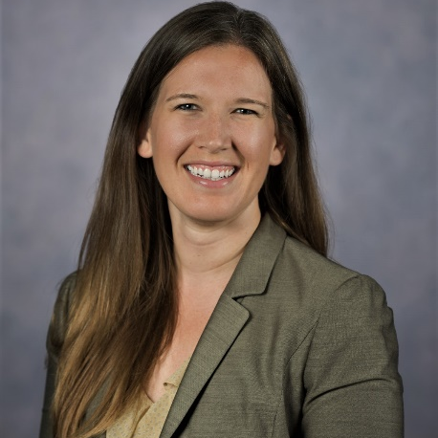
Donna Tope
Donna Tope, MBA, MSHA is the director of Support Services at Tampa General Hospital. Key components of this role include oversight of a twenty-five million dollar operating budget, leading approximately 350 team members over four different departments and developing interdepartmental relationships with clinical leadership to drive strategic imperatives and operational results.
Donna has been with Tampa General Hospital for over five years and began her career as their 2014-2015 Administrative Fellow. She moved into a leadership role within the Support Services department working directly under the senior vice president of the area and has continued to grow within the organization. She holds a Bachelor of Science in Health Services Administration from Auburn University, Master of Science in Health Administration and a Master of Science in Business, both from the University of Alabama at Birmingham.
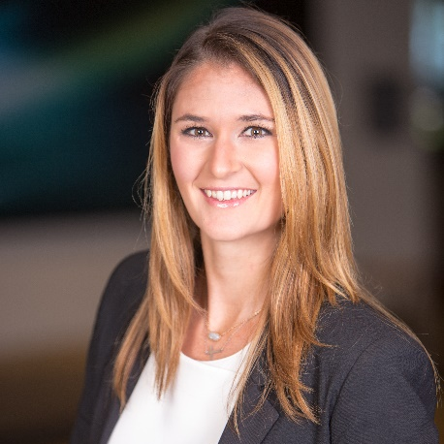
Tallee Williams
Tallee Williams earned her undergraduate degree from the University of Alabama and her master’s degrees from the University of Alabama at Birmingham. She completed both the Master of Science in Healthcare Administration degree and her Master of Business Administration in 2015.
Before coming to Tampa General, Tallee spent over a year and a half at The Emory Clinic in Atlanta, Georgia. She worked in Service Management and the Transplant Clinic in clinical operations, performing service recovery and process improvement projects among the various transplant programs.
After coming to Tampa General in 2015, she was an Administrative Fellow and then moved into the Foundation. She has served as the Project Manager for Hospital Administration for the past year and a half before being promoted to the Manager of Physician Wellness and Special Projects.

Current Fellows
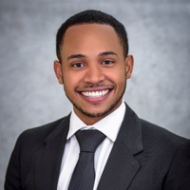
Jordan Clark
Jordan Clark was born and raised in Montego Bay, Jamaica. He graduated from the University of the West Indies with a Bachelor of Law (LL.B) and has acquired his Legal Education Certificate (L.E.C) from the Norman Manley Law School in the West Indies making him eligible to practice law across the Commonwealth Caribbean region. With an appetite for challenges and a desire to expand his professional capacity Jordan is now pursuing his Master of Science in Health Administration from the University of Alabama at Birmingham (UAB).
Jordan entered the UAB Health System in August 2017 as an Intern with the Office of Diversity, Equity and Inclusion. Since then, he acquired his Lean Six Sigma Green Belt Certification and began working with the Performance Excellence team there to improve operational efficiency, remove waste and standardize processes.
Jordan is currently an Administrative Fellow at Tampa General Hospital. Having experienced the shortcomings of 3rd World Healthcare System, Jordan has developed a desire to understand and contribute to improving Healthcare quality, reducing costs, and increasing access to Healthcare services globally. Outside of work he enjoys playing sports, swimming and spending time outdoors with his Floridian friends and family.
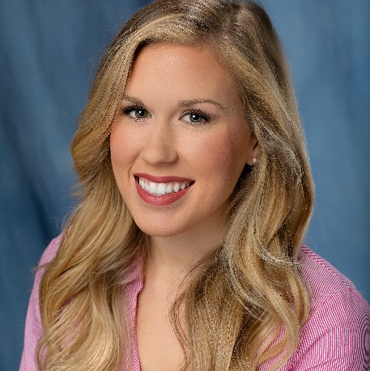
Kathryn Kastner
Kathryn Kastner attended the University of Florida for both undergraduate and graduate school. She completed her Master of Healthcare Administration in 2019 before starting as an Administrative Fellow at Tampa General.
In her time pursuing her graduate degree, Kathryn worked for UF Health, the university’s affiliated hospital. For a year, she worked with Graduate Medical Education within the College of Medicine. During this time, she was heavily exposed to the clinical side of the hospital and the components associated with physician coverage within an academic medical center.
Her second year in graduate school was spent as an intern for the hospital’s administrative team. In this role, she worked on various projects that included areas of quality improvement, finance, and operations. She also was involved in special projects for Children’s Miracle Network at UF Health.
Kathryn hopes to pursue a career in the inpatient setting upon completion of the fellowship and has diverse interests in operational efficiency, project management, and the foundation.
SECTION V: FREQUENTLY ASKED QUESTIONS

What are you looking for in a fellowship candidate?
At TGH, we are looking for self-driven and independent, strategic thinkers. We want our fellows to build relationships, be team players, and contribute to finding new, innovative solutions to today’s healthcare challenges.

What level of experience is required to apply for the fellowship?
We strongly encourage that applicants have experience within the health care profession, whether it be through an internship, volunteer opportunity, or full-time employment. However, TGH welcomes applicants to apply regardless of their level of experience.

Can I apply to both fellowship programs?
Yes, however, to apply to both the finance and administrative fellowship, two separate applications must be submitted to the appropriate team.

Do I have to be a Master’s student to apply?
Yes. Due to the nature of the fellowship process and the expectations when performing project work around the organization, the fellowship is a Master’s level position. Applicants must have completed Master’s coursework to apply.

Do you accept individuals who have already earned their Master’s degree and are not currently an academic student?
Yes, we do accept those applications.

How many fellows are you taking and how long is the fellowship?
We will accept up to two administrative fellows and the fellowship will last one year.

Have fellows succeeded at TGH in the past?
Many fellows have gone on in their careers to succeed at TGH. Former fellows have risen to leadership roles throughout the organization, including Vice Presidents, Directors, Nursing Administrators, and Business Operations Managers. Former fellows have also taken on roles in Strategic Planning, Operations, Ambulatory Care, and Project Management.

Am I guaranteed a job after completing my fellowship?
No. While TGH has a rich history of hiring fellows, there is not a job guarantee at the end of the fellowship.

What types of projects do fellows complete during their fellowship?
Fellows will have the opportunity to delve into a variety of projects in specific areas based on their interests and the needs of TGH. The fellowship is a hybrid model of rotational experience and project work.

What are the salary and benefits?
The Administrative Fellowship Program salary and benefits are competitive with other programs.

How will candidates advance through the interview process?
If selected, candidates who are chosen to advance will be interviewed via phone, and a select few will then be invited for an on-site interview.

If offered, how long do I have to decide?
We will extend offers on Monday, November 11th. Candidates will be given until Friday, November 15th at 5:00 PM EST to accept.

SECTION VI: IMPORTANT DATES

August 19, 2019 | Applications open on https://www.tgh.org/careers and information made available online for Master’s students expressing interest
September 30, 2019 | Applications close at 11:59 PM EST
October 1-31, 2019 | Review of Applications and On-Sites
November 11, 2019 | Offer Date
November 15, 2019 | Deadline to Accept Offer—5:00 PM EST

