The purpose of the TGH Imaging Operational Review Form is to assist study teams, TGH Imaging units, administration/leadership, and the TGH Office of Clinical Research (OCR) in supporting the unit awareness of research conduct and determining the impact of a proposed study on the Unit’s resources.

INSTRUCTIONS FOR STUDY TEAM SUBMITTER:
- Complete sections one through five of the form below.
- Upon completion, submit this form to research@tgh.org.
NOTES:
- This form is ONLY for Imaging done at the TGH main Hospital and/or the Brandon Healthplex. If your study needs outpatient Imaging at TGH Imaging Powered by Tower, please utilize the TGH Imaging Powered by Tower (Outpatient) Intake Form found on the research page of TGH’s website, found here.
- If you require multiple different TGH Imaging departments, complete a different form for each department.
- This form is currently set to track changes. Your text will be red, this is intentional. Please keep the form in this mode and submit this form as a Word document.

Section 1: Basic Study Information
Sponsor:
Short Name/Protocol Number:
Site Number:
PI Name:
PI Employer:  (This is required to know which entity is contracting with the sponsor) | ☐ USF; specify College of Medicine department:  ☐ TGH (or any of the following: Teamhealth, Florida Orthopedic Institute, Florida Kidney Physicians)
Study Coordinator’s Name:
Study Coordinator’s Email:
Type(s) of funding:  (Select all that apply) | ☐ Industry  ☐ Non- Industry
Patient Population:  (Age range, disease group, etc.) | ☐ Greater than or equal to 18 years old  ☐ Less than 18 years old  Disease group:  Other Information:
Projected Enrollment (for site):
Duration of Study (years):
High Priority? | ☐ Yes (OCR approval required)  ☐ No

Section 2: Required Documents
Please include the following documents along with this form. The highlighted documents are required. The remainder should be provided if they are available. | ☐ Study Protocol  ☐ Imaging Manual and/or Acquisition Guidelines (if the study has them, some studies where the imaging sequences/protocols follow standard modalities do not have these documents)  ☐ Digital Uploading and Query Management Manual (if separate/applicable)  ☐ Other Radiology Documents

Section 3: Impacted TGH Imaging Unit
Radiology Unit Name:
Unit Manager:
Unit Director:
Other Managers:

Section 4: Imaging-Specific Information |  | Additional Comments:
Are test images required prior to protocol initiation? | ☐ Yes (i.e. setting print out, phantom/volunteer scan)  Please specify if the study team will be uploading test image(s): ☐ Yes ☐ No  ☐ No
Will the monitor conduct an On-Site Visit with TGH Imaging? | ☐ Yes; Date of anticipated site initiation visit (SIV; if known):  ☐ No  If unknown, state TBD in the comments.
Are the scans required to be anonymized? | ☐ Yes; please specify the naming convention:  ☐ No
Are there any sponsor-required trainings? | ☐ Yes; please specify personnel and responsibilities:  ☐ No
Does the study require Powershare? | ☐ Yes  ☐ No  If Yes, who will upload the images?  ☐ USF/TGH Research staff  ☐ TGH Imaging tech (please note that TGH Imaging staff will only upload the images if the sponsor requires images to come directly from the imaging team)

Section 5: Imaging-Specific Information
Instructions:
- Please list all Protocol required imaging being requested from TGH Imaging, even if SOC.
  - Imaging CPT codes:
  - Note: not all the scans that TGH Inpatient Imaging offers are on the PDF above. Examples: DSA and MRA w/contrast are not on the CPT code PDF above, but TGH Imaging does offer those exams.
  - Please click here to search for testing/diagnostic procedures offered at TGH.
Item: Radiology Test Procedure  (Include whether the scan includes contrast and special requirements) | Exam Frequency Per Patient | Local/Central Read | CPT Code  (if known) | Additional details/requests (ex. Special read requests) | Requires PowerShare:  Y/N
Example Row: Chest X-Ray | 4 visits require the scan | Local and Central required. | 71045 | 2 views | N

RESEARCH TEAM, STOP, YOU DO NOT NEED TO COMPLETE THE REMAINING SECTIONS OF THIS FORM
Section 6: Imaging Manager funding review
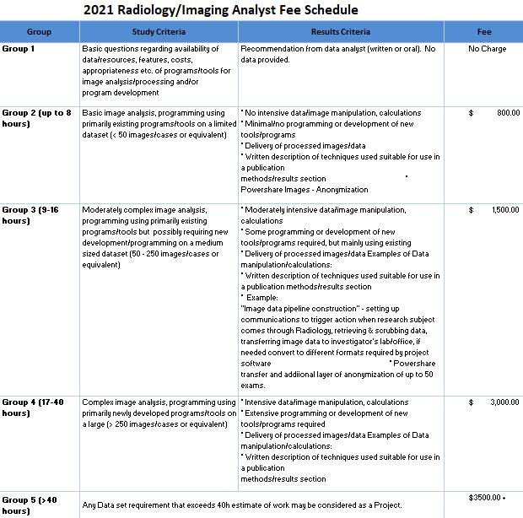
Budget Group (refer to rate Sheet)

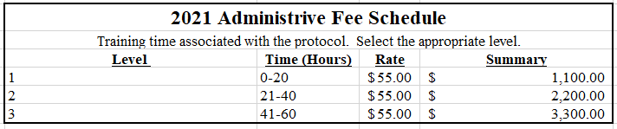
Administrative Fee level:

Section 7: Imaging Manager Determination
This section is to be completed by the Imaging department manager or Unit Director after working to determine the feasibility of facilitating this study on the unit based on the impact on the units’ operations.
- The TGH OCR Clinical Research Program Coordinator will only route this form for signature after working with the Imaging Manager to determine if the study is feasible.
Yes, feasible
No, not feasible
Comments
Your signature on this form indicates that the imaging requests above are feasible.

Role: | Name (Print): | Signature: | Date:
Unit Manager

Study Team Representative

